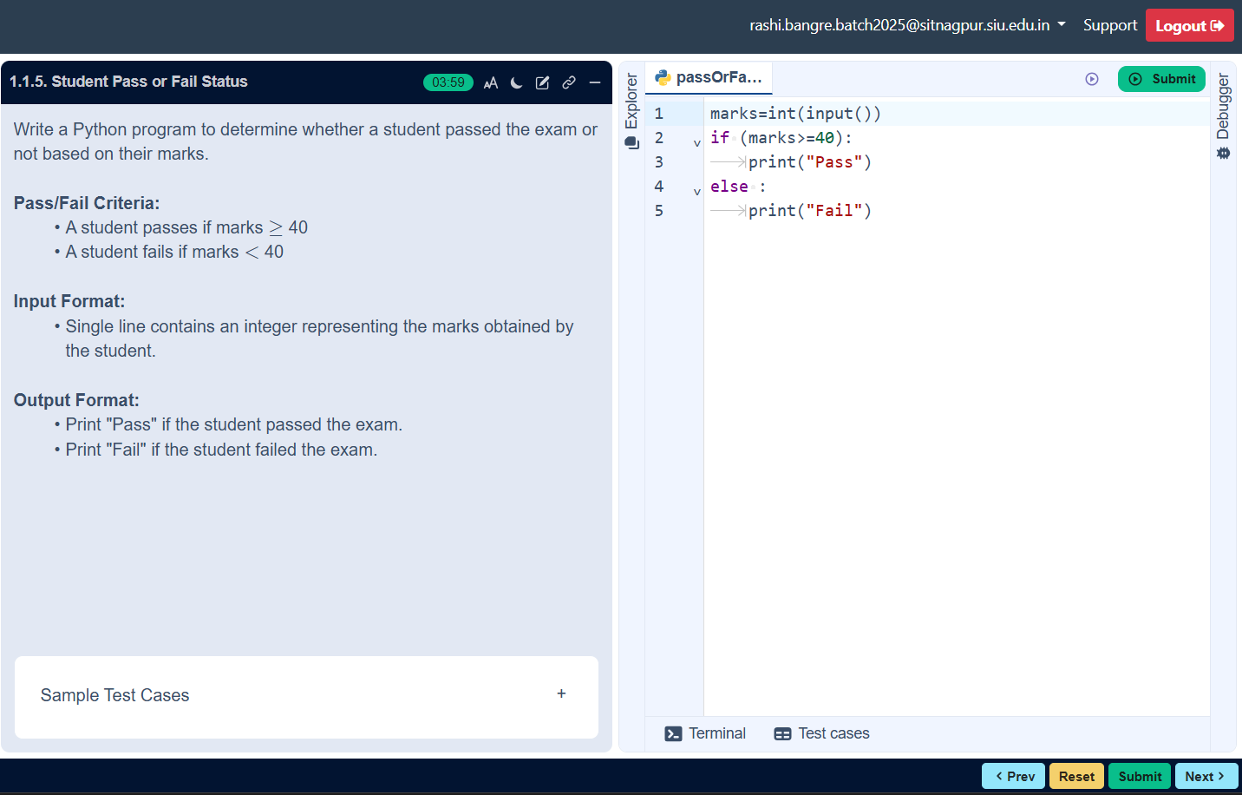
ALGORITHM
Step 1: Start
Step 2: Input marks
Step 3: Check condition
if marks ≥ 40
print”Pass”
else
print”Fail”
Step 4: Stop

FLOWCHART

STUDENT PASS OR FAIL
